**Name** : Zeyad Ahmed Youssry Mohamed

**B.N**: **21**

**Date** :

**Topic** : programming language

**Application Brief:** I choose the programming languages as it allows to give instructions to a computer in a language the computer understands .just as many human-based languages exist , there are an array of computer Programming languages that programmer can utilize to contact with a computer  The portion of the language that a computer can understand is called a “binary.” Translating programming language into binary is known as “compiling.” Each language, from C Language to Python, has its own distinct features, though many times there are commonalities between programming languages.

**screen shots :**

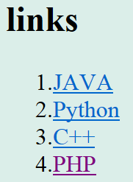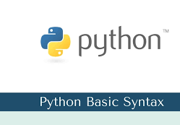

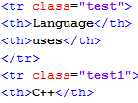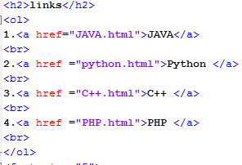**Source code :**